Activity 8.1 - Continental Drift

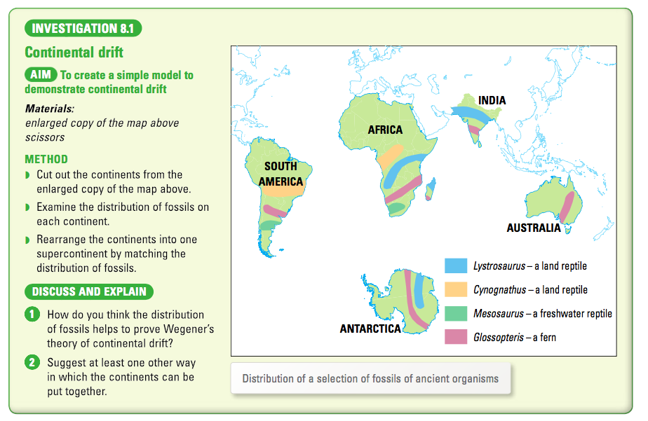

Cut out the continents on the following page and see what happens.

Take a photo and add it in the space to the right. Answer Q 1 and 2.
